This document will present the steps needed to Install / Un-install the drivers of MosChip PCI to Serial / Printer port products or another manufacturer’s product based on MosChip MCS98XX series.
In this document, the MCS9835 is taken as an example to explain the installation process.
MCS9835 offers two serial ports and one printer port.

Driver Installation:
Download the appropriate drivers from the link www.moschip.com
The drivers can be downloaded from the category “PCI Connectivity” in the download section of our website.

Allow the “.zip” file to be downloaded to your local computer.
Unzip the Driver files to a directory on your PC Hard Disk, or to a Floppy Diskette.

Installing Drivers for the first time:
Switch OFF the PC.
Insert the peripheral card into the computer.
Ensure that there are no external devices connected to the Ports at this time. They can interfere with the installation of the Drivers.
Turn ON the computer.
Windows should detect the new card, and automatically invoke the “Found New Hardware” wizard.
Select “Install from a list or specific location (Advanced)” and click on “Next” to start the installation.

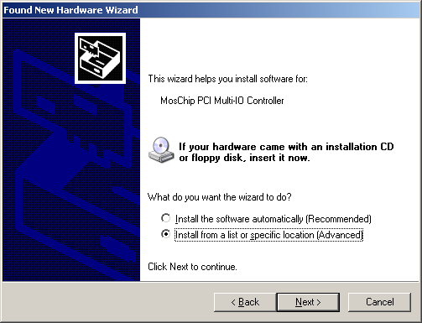

Select the location of the driver disk by using the option “Browse” and click on “Next” to proceed further.

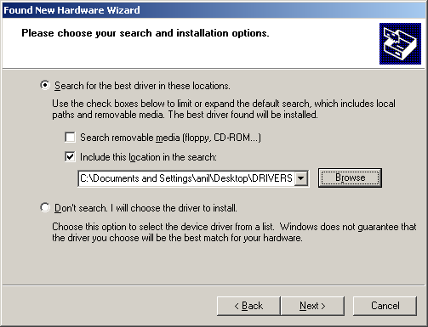

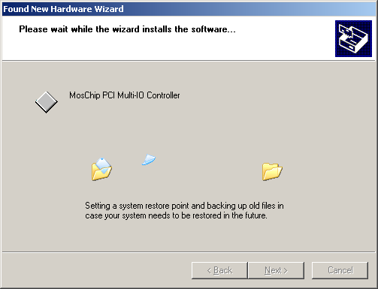

Click on “Finish” to complete the MosChip PCI Multi-IO Controller installation.

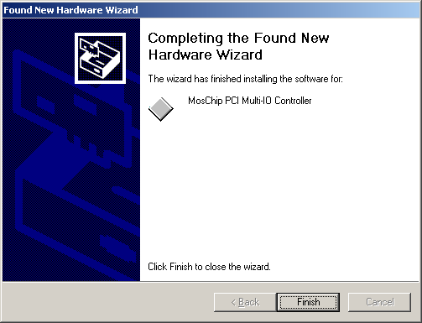

Follow the same procedure to install the MosChip PCI Printer port and Serial ports.
Confirm proper detection of the MCS9835 card by viewing the Device Manager.

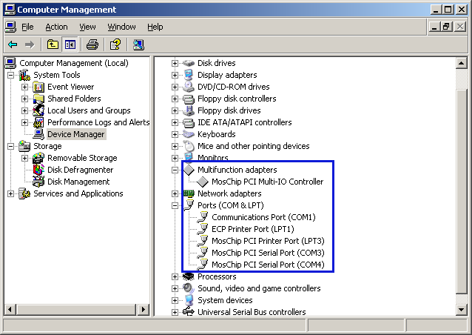

Un-Installing the drivers:

Sometimes it will be desirable or even necessary to remove the previously installed drivers, so that a new, clean installation can be performed. Drivers can get corrupted when being written to their installation medium (CD-ROM etc.). If this happens, the drivers may not install properly.
Even if the installation proceeds without errors, the drivers may not work. Sometimes older outdated drivers are shipped with a product. Newer machines may require newer updated drivers, but the older drivers prevent them from being installed.
The easiest way to remove old drivers is to use the “NMUNINST.EXE” program.

Double click on “NMUNINST.EXE” which pops up a Multi-I/O drivers uninstall utility as shown below.

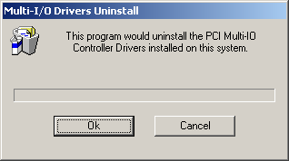

Upon driver un-installation, the OS prompts the user to reboot the system. Please restart the system for the changes to take effect.

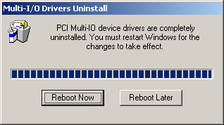

Please get in touch with us at support@moschip.com for any queries / suggestions that you may have for us.

